**Clustering Cities in Gujarat State of India based on Demographic, Education and Location Data**

**1. Introduction/ Business Problem**

**Description & Discussion of the Background**

**Gujarat** is a state on the western coast of India with a coastline of 1,600 km (990 mi) and a population in excess of 60 million. It is the sixth largest Indian state by area and the ninth largest state by population. The economy of Gujarat is the fifth-largest state economy in India with ₹14.96 lakh crore (US$210 billion) in gross domestic product and a per capita GDP of ₹157,000 (US$2,200).

As you can see from the figures, Gujarat is a great state to live in. When we think of this from the perspective of an immigrant, we can ask the question：

1. Where is/are the best city/cities to live in Gujarat?

2. How can the cities be categorized according to demographic, educational and location data?

When we consider all these problems, we can cluster the cities according to the data described in the section below.

**2. Data Description**

To consider the problem, I have listed the data that will be used in the project as below:

* List of Cities (District Headquarters) from District Table - https://en.wikipedia.org/wiki/List_of_districts_of_Gujarat

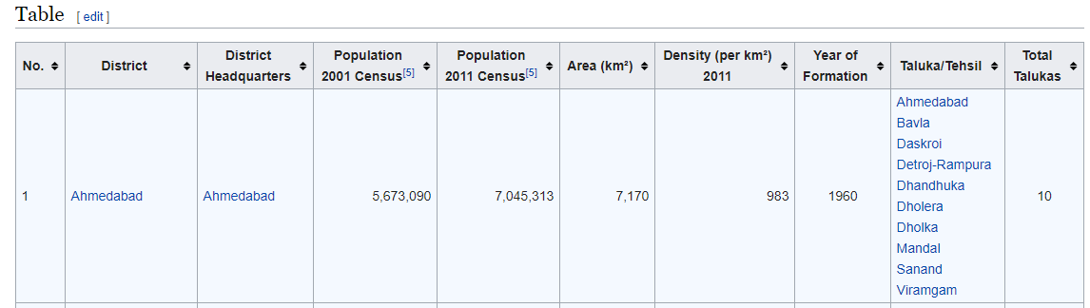

* Kaggle Dataset - 2015-16-District-wise Education Data India

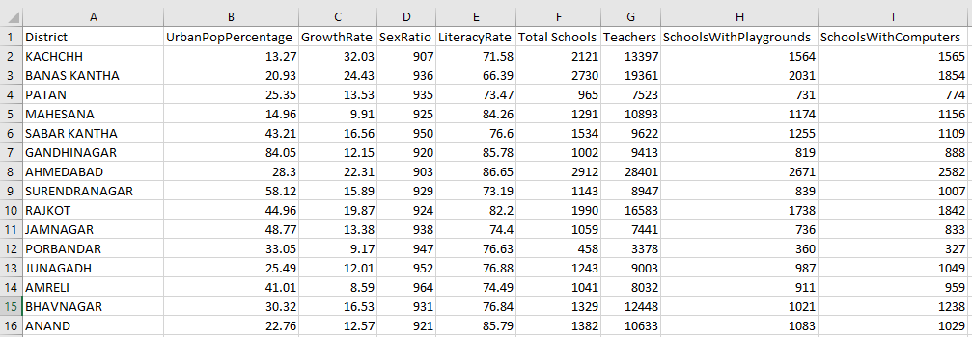

* Geo Location Data - Geocoder Library/API
* Location Data - Total Venues per City - Foursquare API